Digital Badge Archiving and Display with Credly:
1. One place you may elect to create an account to display your digital badges is via Credly.
Go to https://credly.com/ and scroll all the way down to the bottom of the page until you see this:

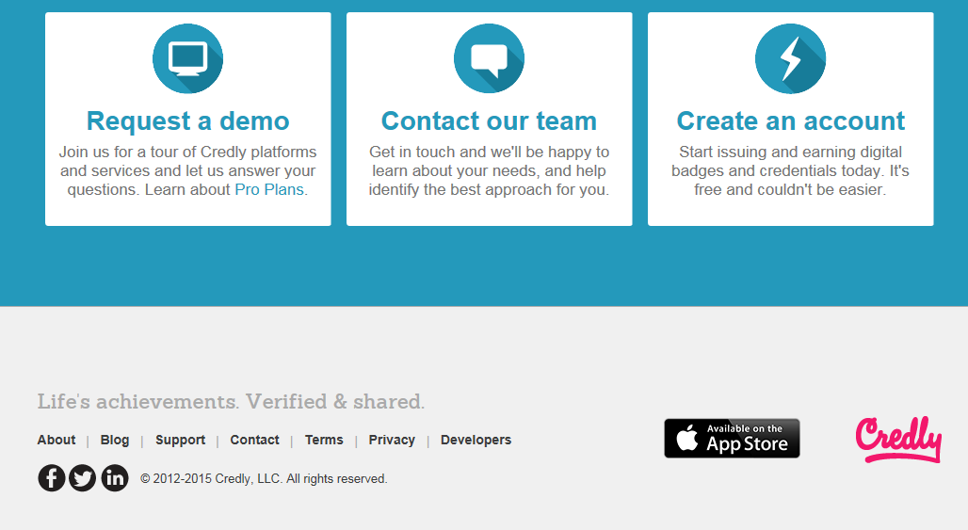
2. Click on “Create an account”. You will note that this is free and the setup is similar to setting up a free email account (like some have on Google, Yahoo! or Hotmail).
3. When you reach this page, you’ll see you have three options to create your account. It is strongly suggested that if you are going to be collecting badges that are linked to a career that you also have a Linked In account and connect your Credly account to it.
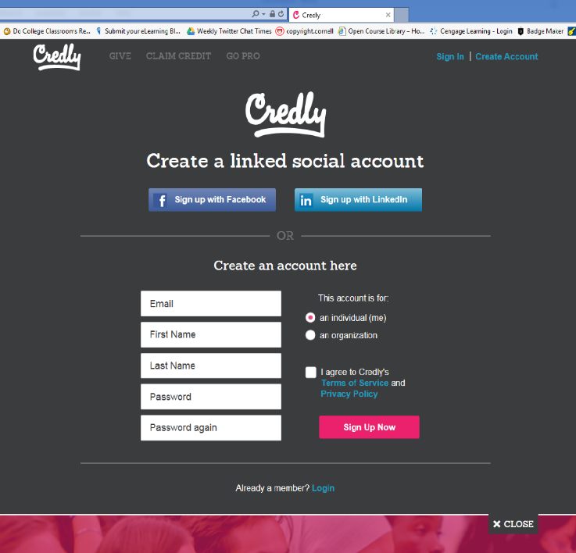
If you already have a LinkedIn account, it is highly suggested you create a linked social account to display your badges so employers can see them.

4. Once you have created your account, you can customize it by adding your photo, decide which badges to display and which ones to hide.
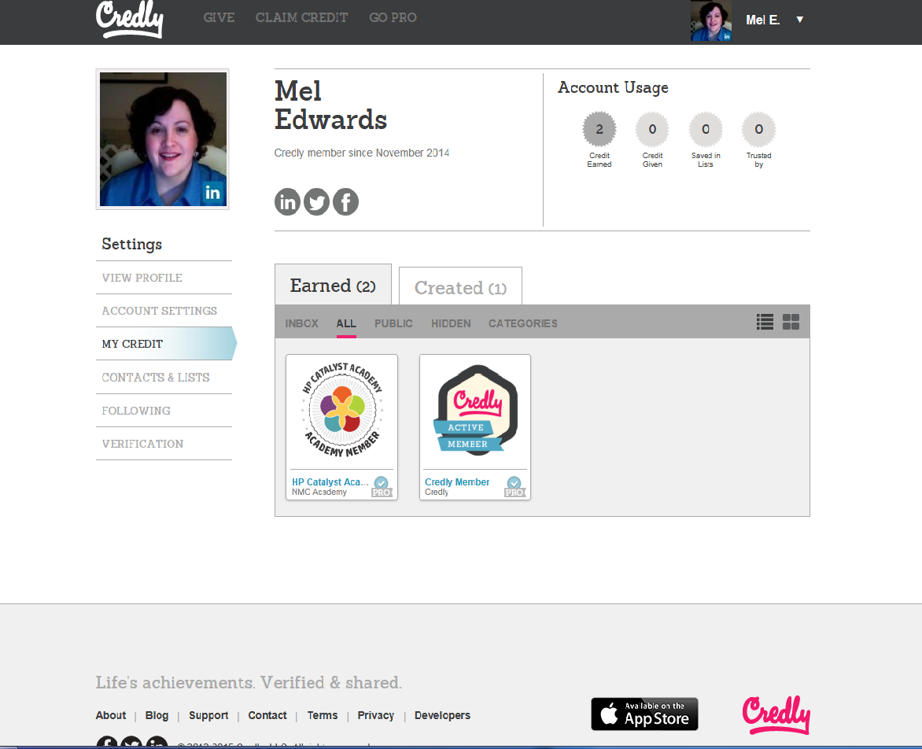
You decide if your badges are public or private, and if you want to share them via Facebook, LinkedIn or Twitter.
5. Furthermore, you can even create your own badges for serious or silly reasons.
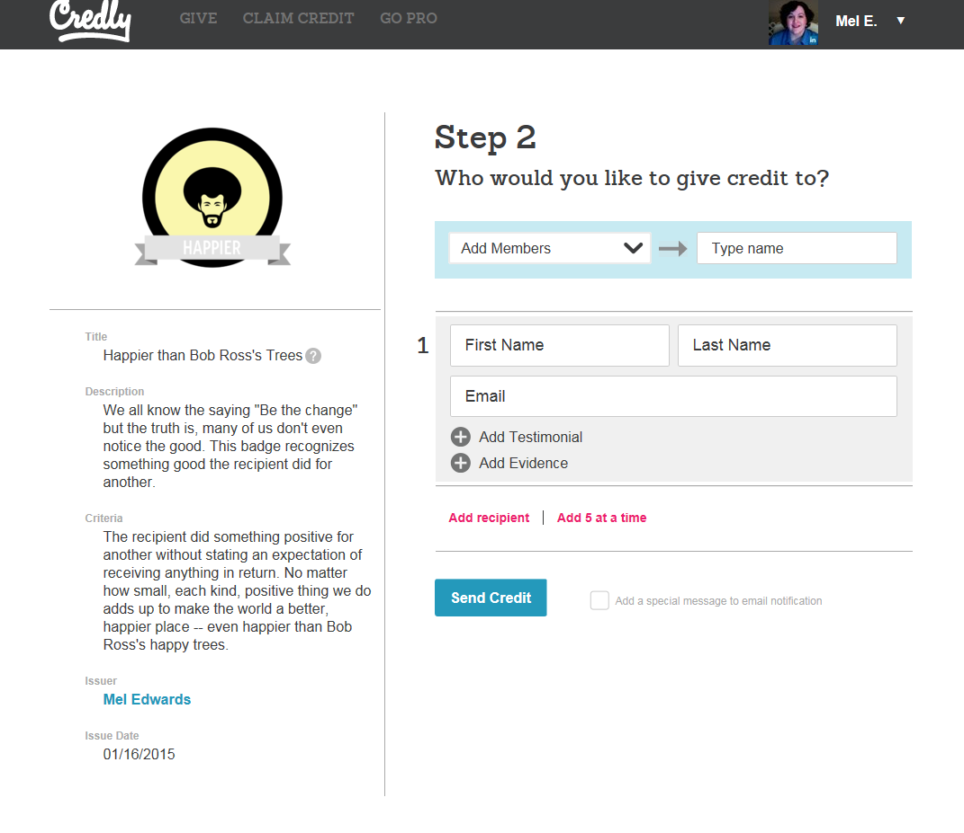
The ONLY drawback to Credly is that any badge you display will NOT be verified, and you’ll need to keep your original email verifying the validity of your badge for proof that YOU really earned it.

