Tellagami® is a collection of innovators, technology gurus and creative artists in San Francisco exploring new ways to bring your messages to life. By combining photos, voice, 3D character customization and personality on a mobile platform, we help you communicate in a way that's never been possible (from website: https://tellagami.com/edu/)

Using Tellagami to design your own course introduction:
- Select your avatar
- Customize hair, skin tone, shirt, pants, shoes, emotion
- Select background: classroom, office, park, etc.
- Record your 90 second introduction (see practice transcript below)

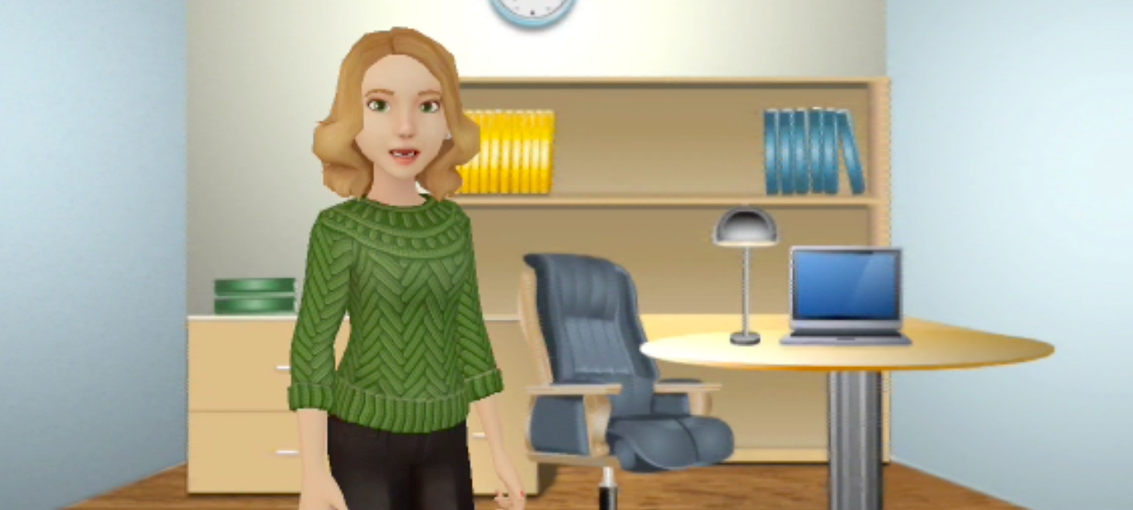

Practice Transcript

Hi – I’m (your name) and welcome to (Course Number and Title)
Greeting and introduction

Our first class is Tuesday, September 7th – and if you have any questions and would like to check in, you’ll find my contact information on the syllabus. My office is located in Horace Mann in room 067 or you can email me at (your email address).

Together we’ll explore the characteristics and needs of young children – looking across all domains of learning and development. Click on “Course Introduction” and I’ll walk you through the Blackboard modules to help you become familiar with our course.
Course description
Purpose of course
I look forward to working with you this semester and guiding you along your path to becoming a high-quality, certified early childhood educator.

