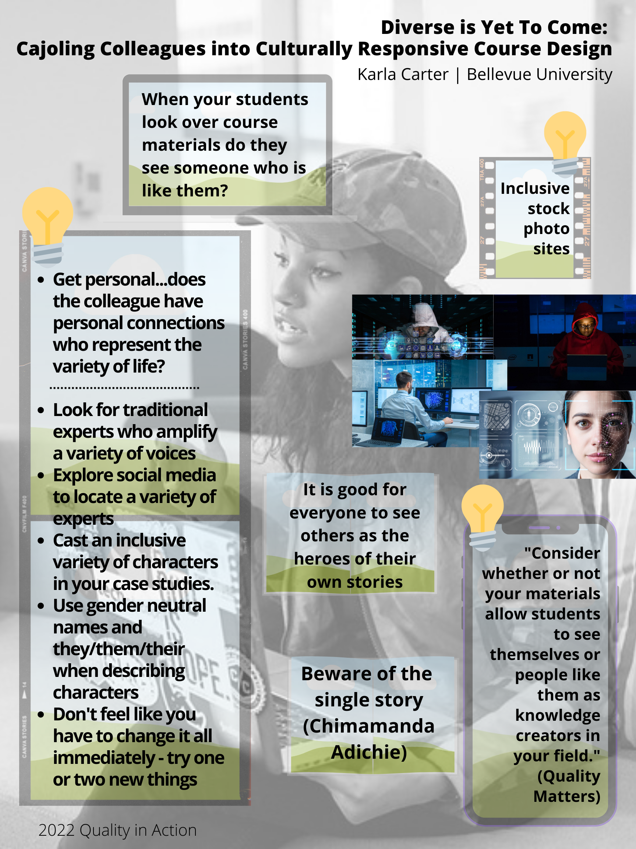

Links
#WOCinTech Chat Creative Commons stock photos https://www.flickr.com/photos/wocintechchat?s=09 (photos used in poster)
PICHA free XS images https://pichastock.lpages.co/xs-free-image/
The Stockpile by CreateHER https://createherstock.pixieset.com/2020-photo-packs/
Alex Bayley’s Diverse and inclusive stock photography https://alexbayley.id.au/resources/diverse-and-inclusive-stock-photography/
Support Student Success With Culturally Responsive Course Design https://www.qualitymatters.org/qa-resources/resource-center/articles-resources/culturally-responsive-design
The danger of a single story by Chimamanda Adichie https://www.ted.com/talks/chimamanda_ngozi_adichie_the_danger_of_a_single_story

