Tips for Audio Recording

The following are some important tips to consider when recording audio. Following these tips will help you create audio presentations that are clear and understandable.

- Make sure you are well rehearsed, physically comfortable, and in an upright or standing position.
- Plan for the appropriate amount of time so you do not feel rushed. When scheduling your time, you will want to allow at least 2.5 times the length your presentation. As an example, if your presentation will last 10 minutes when done, you will want to allow for 10 minutes to record the initial audio, 10 minutes to listen to it, and at least 5 minutes to re-record to correct any mistakes.
- Minimize the room’s influence on your recording. Ambient noises (e.g. dogs, kids, fans, vents, office chairs, etc.) can distract from an otherwise clear recording of your presentation.
- Try to stay consistent. Use the same room; maintain the same settings on your equipment; and present at the same distance from the mic with a steady speaking level.
- Place your microphone away from your computer. You might not realize this, but your computer makes a lot of noise (especially your keyboard and computer fan).
- Use a good quality microphone. It doesn’t have to be expensive to sound better than what is built into your laptop.
- Choose an appropriate microphone - preferably those that connect to your computer through the USB port or mobile device:
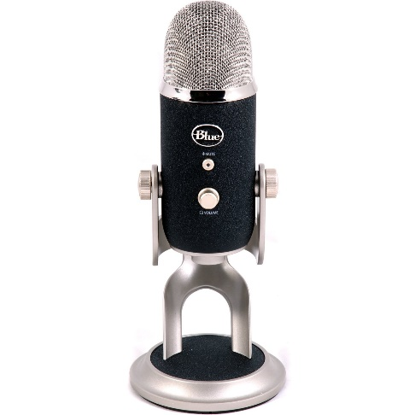  Blue Desktop Microphones | 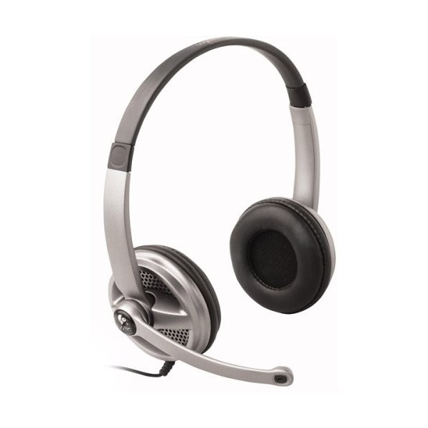  Logitech USB Headsets | 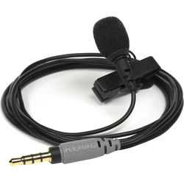  Microphones for Mobile Devices

- Place the microphone at the proper distance and speak slightly off center instead of directly into it. This will help to minimize popping sounds on hard consonants. Keeping the microphone approximately 3”- 6” away from your face is a rule of thumb, but it also depends on the type of microphone you are using.
- Every microphone is different so you will want to perform a test recording and if necessary adjust the position of the microphone to ensure the best results.
- Speak clearly and enunciate. Certain verbal sounds are more difficult than others for microphones to pick up clearly.
- You are not in a classroom! Relax, and keep in mind that you do not need to strain your voice so the students in the back can hear you. Speak at a conversational level.

