A Blended Community of Inquiry
Contribute to the Community with your Ideas and Suggestions
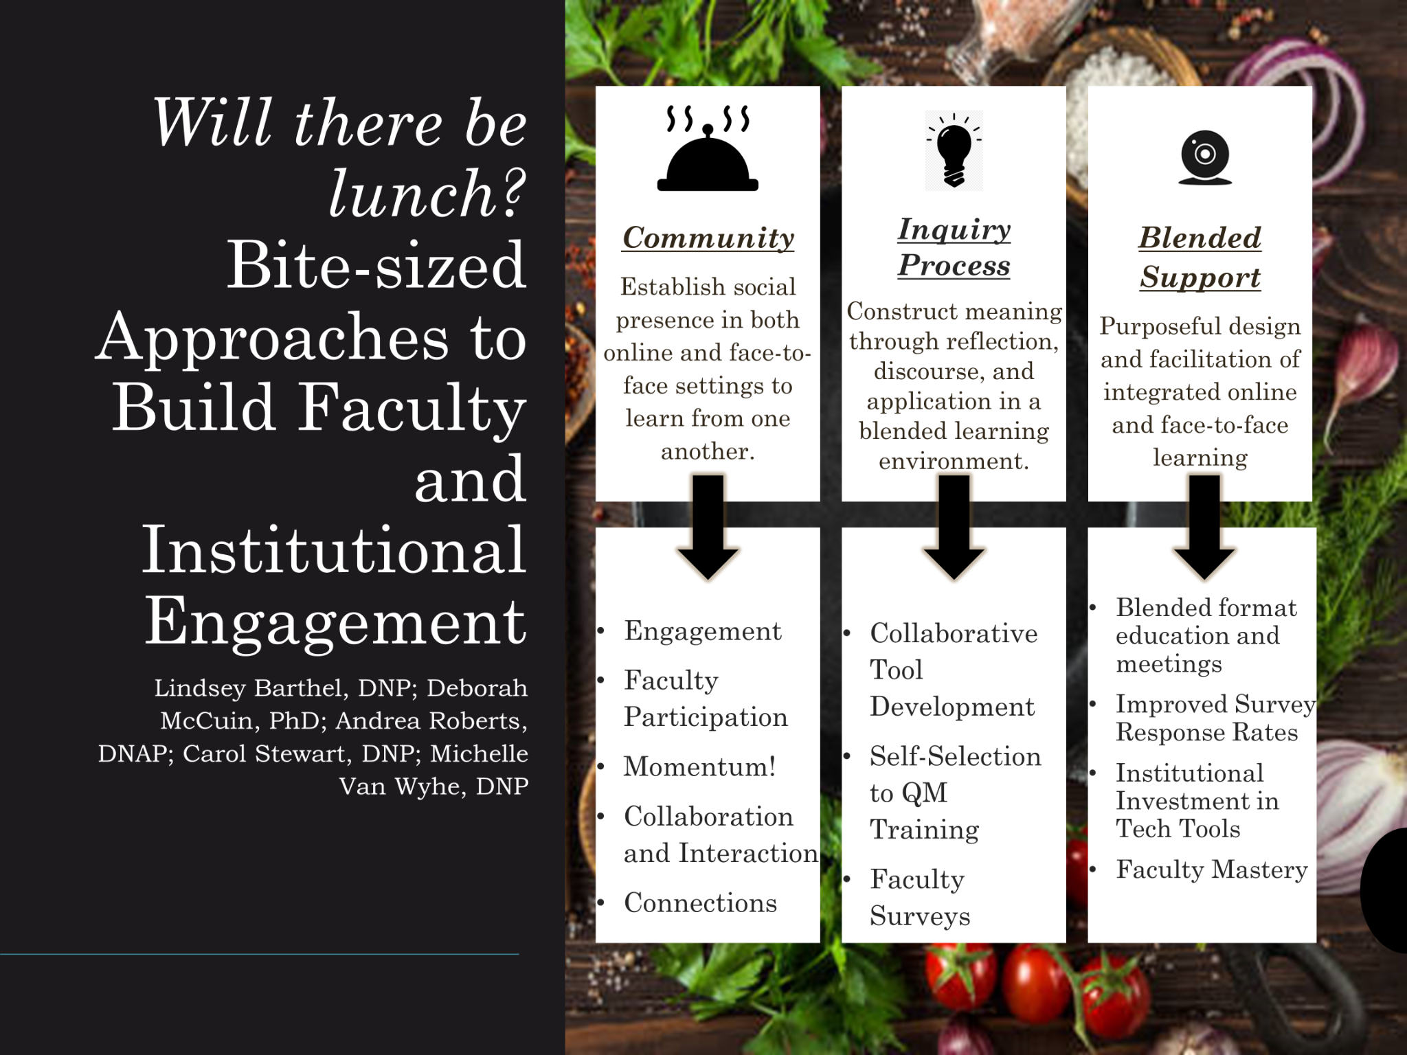
Contact Us:
Lindsey Barthel, DNP; lindsey.barthel@mountmarty.edu
Deborah McCuin, PhD; deborah.mccuin@mountmarty.edu
Carol Stewart, DNP; carol.stewart@mountmarty.edu
Andrea Roberts, DNAP; andrea.roberts@mountmarty.edu
Michelle Van Wyhe, DNP: michelle.vanwyhe@mountmarty.ed

INTRODUCTION
The Community of Inquiry Framework traditionally focuses on the student experience in online courses with a focus on building social, cognitive, and teaching presence within the online learning community. The Blended Community of Inquiry Framework adapts this model to support and create a collaborative space to explore teaching practice within the three spheres of community, the inquiry process, and blended support. This collaborative document encompasses each of these spheres by expanding our community outward, supporting meaningful discourse, and integrating technology.
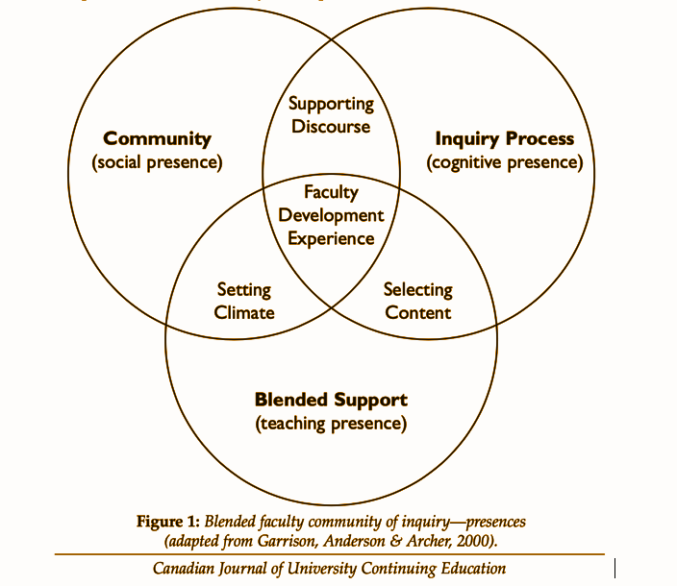

Share your Experience and Knowledge
Share your ideas, experiences, and knowledge with the group through this collaborative document. The team at Mount Marty University will begin with our experience in each of the “spheres” of the Blended Community of Inquiry. Each strategy was incorporated with the goal of building a comfortable, non-threatening, and educational setting to share ideas, knowledge, and gain momentum toward quality assurance!

Community
Community is defined as ways to establish social presence in both online and face-to-face settings to learn from one another.
- Blended workshops focusing on teaching strategies and technology integration. Workshops were hosted live, in-person, with remote access via Zoom.
- One-on-One in person and/or virtual coaching and mentorship.
- Sharing a meal or snacks - provided comfort, a sense of community through sharing a meal, created a non-threatening atmosphere.
- Providing prizes and incentives to both in-person and virtual participants.
- Developed an online course in the LMS to support and expand upon the in-person workshop content.

Inquiry Process
In the Inquiry Process, faculty construct meaning through reflection, discourse, and application in the blended learning environment.
- Collaborative creation of LMS course home page templates.
- Collaborative creation of a standardized syllabus for both in-person and online courses with accompanying training on implementation.
- Sequenced learning sessions to allow faculty to build on prior learning, knowledge, and skills.
- Anonymous faculty surveys created using collaborative tools (Google Docs, Google Forms, etc.)
- Self-Selection for QM training such as Teaching Online Certification, Peer Reviewer, Master Reviewer.

Blended Support
- Faculty Orientation Course using the university’s LMS.
- Blended setting for workshops and “Brown Bag Lunch Series”.
- QM Training.
- Use of collaboration software such as Zoom, Google Docs, Google Forms.

Reference
Vaughn, N., Garrison, R. (2006). A blended faculty community of inquiry: Linking
leadership, course redesign, and evaluation. Canadian Journal of University Continuing
Education, 32(2), 67-92. DOI: 10.21225/D5XK57

